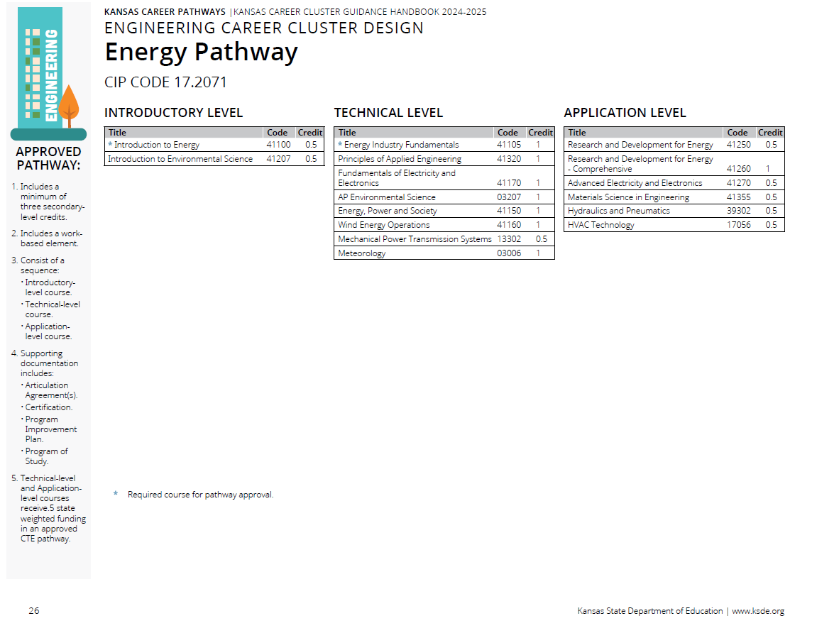
Prior to the Cluster Review

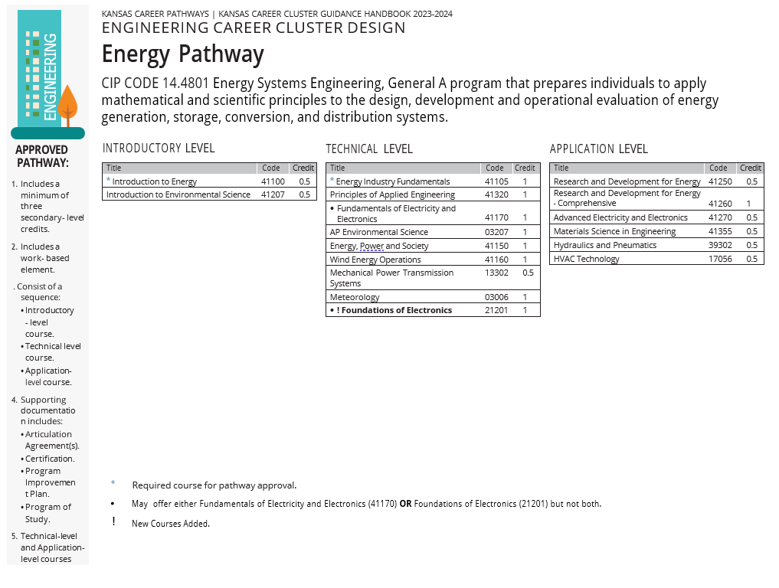
Recommendations Following Cluster Review

Pathway Recommendations Summary:

CIP Code Recommended Change
- New CIP Code: 14.4801 Energy Systems, Engineering, General.

No Recommend Changes CTE Course Competencies and Indicators (ksde.org)
- Courses not reviewed by this committee.
  - 41320 Principles of Applied Engineering
  - 03207 AP Environment Science
  - 13302 Mechanical Power Transmission Systems
  - 03006 Meteorology
  - 41355 Materials Science in Engineering
  - 39302 Hydraulics and Pneumatics
  - 17056 HVAC Technology

Courses Reviewed with Recommended Changes
- Courses with updated competencies and benchmarks
  - 41100 Introduction to Energy
  - 41207 Introduction to Environmental Science
  - 41105 Energy Industry Fundamentals
  - 41170 Fundamentals of Electricity and Electronics
  - 41150 Energy, Power, and Society
  - 41160 Wind Energy Operations
  - 41250 Research and Development for Energy
  - 41260 Research and Development for Energy – Comprehensive
  - 41270 Advanced Electricity and Electronics.

New Course Recommendations
- Courses Recommended to be Added.
  - 21201 Foundations of Electronics
    - Can offer either 41170 Fundamentals of Electricity and Electronics OR 21201 Foundations of Electronics but not both.

